High Level Design Document

TF Reusable Application Flows

Feb 11, 2020

**Updated: 02/11/20**

**Overview**

This document provides the high level design of the Reusable Applications Flows as per the high level analysis of Tax Factory Application pages.

**Scope**

* Define Metadata for Read Only (RO) Type of Grid (User Data Query grids)
* Define Metadata for Type 1 Grid
* Define Metadata for Type 2 Grid
* Define Flow for RO Type 1 Grid component.
* Define Flow for Type 1 Grid component.
* Define Flow for Type 2 Grid component.

**Assumptions**

* Existing Data model from will be used for Permissions storage.
* Browser local storage mechanism would be used for User Preferences.
* Security Service needs to enhance to TF authentication support.

**Constraints**

* Module Descriptor needs to provide valid information to support module in MAC.
* Individual module would provide bundled/generated build file and any other artifacts to support the module at run time along with Module Descriptor.

**Definitions**

* UI – User Interface
* MD – Module Descriptor
* MAC – Module Application Container
* MVC – Model View Architecture
* JSON – JavaScript Object Notation
* CF – Compliance Factory
* TF – Tax Factory
* SWS – Security Web Service

**Areas Impacted**

* Security Web Service needs to updated to support TF module authentication (Not a part of this design)

**High Level Design**

**Read Only (RO) Grid Component Flow**

Read Only Component flow would utilize Type 1 Grid Metadata with all read only columns. Following diagram illustrates RO Component Flow.

**RO Component Prerequisite**

* Read Only Component JSON Metadata definition. For e.g.: Metadata Sample.
* Reusable Library Bundle (.css, images, .js etc.) For e.g.: bsiuilib.js
  1. Type 1Grid component.

**RO Type 1 Flow**

* User clicks on link or sub area in the module. Categorized/identified by pageid.
* Based on the pageid area metadata descriptor will loaded and supplied to the component renderer.
* Type 1 Grid component will utilize the metadata descriptor and render the page.

**RO Component Flow Illustration**



**Type 1 Grid Component Flow**

Type 1 Grid Component flow would utilize Type 1 Grid Metadata with first column with renderer Input defined on the first column and will launched as Modal on module area/subarea click. Link on first column will native to the child grid Following diagram illustrates Type 1 Component Flow.

**Type 1 Component Prerequisite**

* Type 1 Grid Component JSON Metadata definition. For e.g.: Sample Metadata
  1. Grid Metadata.
  2. CRUD Metadata.
* Reusable Library Bundle (.css, images, .js etc.) For e.g.: bsiuilib.js
  1. Type 1Grid component.

**Type 1 Flow**

* User clicks on link or sub area in the module. Categorized/identified by pageid.
* Based on the pageid area metadata descriptor will loaded and supplied to the library based common Grid component for rendering.
* Type 1 Grid component will utilize the metadata descriptor and render grid with first column as link.
* Link click on first column on grid will take user to modal based CRUD screen for the entity/area. Exit on CRUD modal will close the modal and bring user to Type 1 grid.

**Type 1 Component Flow Illustration**



**Type 2 Grid Component Flow**

Type 2 Grid Component flow would utilized Type 2 Grid Metadata with first column with cell renderer defined on the first column. That will generate a link on that column that will launch child grid of Type 1. Child grid will be rendered based on child grid reference childFlowId attribute. Following diagram illustrates Type 2 Component Flow Illustration.

**Type 2 Component Prerequisite**

* Type 2 Grid Component JSON Metadata definition. For e.g.:
  1. Grid Metadata.
  2. CRUD Metadata.
  3. Child Grid Metadata reference provided.
  4. Filter grid attribute (filtergrid) set as true

* Reusable Library Bundle (.css, images, .js etc.) For e.g.: bsiuilib.js
  1. Type 2 Grid component.

**Type 2 Flow**

* User clicks on link or sub area in the module. Categorized/identified by pageid.
* Based on the pageid area metadata descriptor will loaded and supplied to the library based common Grid component for rendering.
* Type 2 Grid components will utilize the metadata descriptor and render Type 1 grid with first column as link.
* If No record available for parent then
* Link click on first column on grid will take user to modal based CRUD screen for the entity/area. Exit on CRUD modal will close the modal and bring user to Type 1 grid.

**Type 2 Component Flow Illustration**



**UI Technology Stacks**

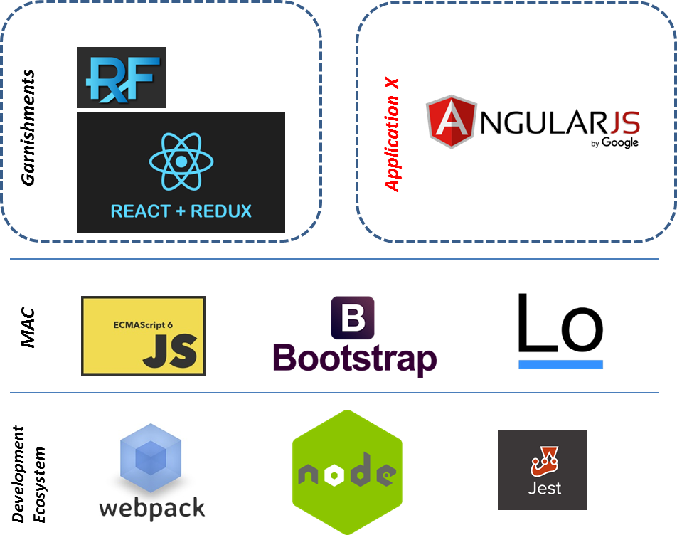

**Service/Batch Process Technology Stacks**

